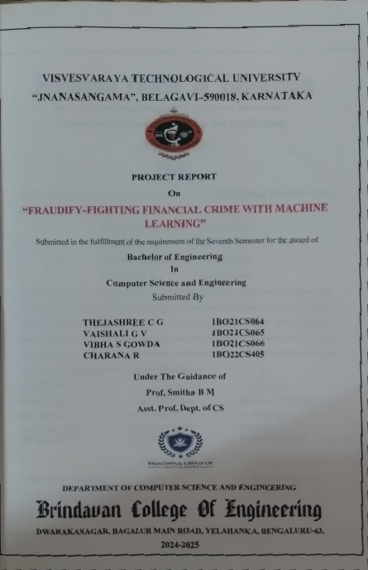



ABSTRACT

Unified Payments Interface (UPI) has revolutionized digital transactions, offering seamless, instant payments in India. However, the widespread adoption of UPI also introduces significant concerns regarding security, with increasing instances of fraud. The emergence of fraudulent activities, including identity theft, phishing, and unauthorized transactions, highlights the urgent need for robust fraud detection systems. Traditional rule-based methods are often inadequate in addressing the dynamic and sophisticated nature of UPI fraud, which necessitates the exploration of machine learning (ML) techniques to enhance detection efficiency.

Machine learning algorithms, particularly classification and anomaly detection models, have shown great promise in identifying fraudulent transactions. This report explores the application of various ML models, such as decision trees, random forests, support vector machines, and neural networks, to detect fraudulent UPI transactions. The models are trained using a large dataset containing both legitimate and fraudulent transaction data, enabling the algorithms to recognize patterns and classify transactions accordingly.

In the process, the report also compares the performance of different machine learning models, evaluating their accuracy, precision, recall, and F1 score to determine the most effective approach for fraud detection. The results demonstrate that ensemble methods like random forests provide high accuracy and reliability, while deep learning models such as neural networks offer improved performance in detecting complex fraud patterns. Additionally, feature engineering plays a critical role in enhancing model performance by identifying key attributes that distinguish legitimate from fraudulent transactions.

The findings of this study underscore the potential of machine learning in transforming UPI fraud detection and provide valuable insights for implementing more advanced, automated systems. By integrating these models into UPI platforms, financial institutions can proactively monitor and mitigate fraudulent activities, safeguarding users and maintaining trust in digital payment systems. Future research may focus on real- time detection, model optimization, and the use of more diverse datasets to further enhance the system's robustness.
.

ACKNOWLEDGEMENT
The satisfaction and euphoria that accompanies the successful completion of any task would be incomplete without mentioning the people who made it possible. With deep gratitude, I acknowledge all those guidance and encouragement, which served as bacon of light and crowned our efforts with success. I thank each one of them for their valuable support.
We express my sincere thanks to Dr. B.R. Shetty, Chairman, Brindavan College of Engineering, Bangalore, for providing necessary facilities and motivation to carry out Project work successfully.
We convey my sincere thanks to Dr. Shruti Sharma, CEO, Brindavan Group of Institutions for her support and motivation.
We wish to express my sincere thanks to Dr.Venugopal A R, Director, Brindavan Group of Institutions for his support and motivation.
We express my sincere thanks to Dr. Bhagappa, Principal, and Brindavan College of Engineering for providing necessary facilities and motivation to carry out project work successfully.
We express my heartfelt gratitude and humble thanks to Dr. Avinash N, Head of Dept, CSE, Brindavan College of Engineering, for the constant encouragement and help to carry out project work successfully.
We take this opportunity to express our sincere gratitude to Project Coordinator Prof. Mamatha M, Assistant Professor, Dept. of CSE, and Brindavan College of Engineering for encouraging us throughout the Project work.
We would also like express my humble thanks to Project guide Prof. SMITHA B M , Assistant Professor, Dept. of CSE, Brindavan College of Engineering for guiding and having facilitated us to complete our project work successfully.
We would like to mention our special thanks to all the faculty members of Computer Science and Engineering Department, Brindavan College of Engineering for their invaluable support and guidance. We finally thank our family and friends who have been encouraging usconstantly and inspiring.

THEJASHREE C G – 1BO21CS064 VAISHALI G V – 1BO21CS065 VIBHA S GOWDA – 1BO21CS066 CHARANA R – 1BO22CS405

Sl. No | Titles | Page. No
1 | Abstract | i
2 | Acknowledgement | ii
3 | Table of Contents | iii
4 | List of Figure | v

Chapter No. | Titles | Page. No
1 | Introduction | 1-5
 | 1.1 Overview | 1
 | 1.2 Problem Statement | 1
 | 1.3 Significant and Relevance of work | 2
 | 1.4 Objective | 3
 | 1.5 Methodology | 4
 | 1.6 Organisation of the report | 5
2 | Literature Survey | 6-9
3 | System Requirements and Specification | 10-11
 | 3.1 Hardware Specification | 11
 | 3.2 Software Specification | 11
 | 3.3 Functional Requirements | 11
 | 3.4 Non-Functional Requierments | 11
 | 3.5 Performance Requierment | 11
4 | System Analysis | 12-14
 | 4.1 Existing System | 12
 | 4.2 Proposed System | 14

5 | System Design | 15-19
 | 5.1 System Architecture | 15
 | 5.2 Sequence Diagram | 17
 | 5.3 Data Flow Diagram | 18
 | 5.4 Class Diagram | 19
6 | Implementation | 20-25
 | 6.1 Language Used | 20
 | 6.2 Implementation Technologies | 23
 | 6.3 Sample Code | 25
7 | Testing | 26-29
 | 7.1 Test Cases | 29
8 | Result & Discussion | 33
 | Conclusion | 34
 | Future enhancement | 35
 | References | 36
 | Appendix A | 38
 | Appendix B | 39

Fig. no | Fig. | Page no.
5.1 | System Architecture | 15
5.2 | Sequence Diagram | 17
5.3 | Data Flow Diagram | 18
5.4 | Class Diagram | 19
8.1 | Home Page | 30
8.2 | Login Page
8.3 | Upload Dataset | 31
8.4 | Valid Transaction
8.5 | Fraud Transaction | 32
8.6 | Pie Chart for Fraud Vs Original Transaction
8.7 | Bar Chart for Fruad Vs Original Transaction | 33
8.8 | Android app Snapshot
8.9 | Dashboard | 37
8.10 | Test Case UI
8.11 | Suspicious Transaction | 38
8.12 | Fraudulent Result

CHAPTER 1

INTRODUCTION

OVERVIEW

The Unified Payments Interface (UPI) has revolutionized digital payments, offering users a seamless, secure, and efficient platform for financial transactions. UPI’s widespread adoption across individuals and businesses has transformed the way money is exchanged in the digital economy. However, this growth has also made UPI systems vulnerable to fraudulent activities, such as phishing scams, fake UPI IDs, and unauthorized transactions. The need for robust fraud detection mechanisms is critical to maintaining trust and security within this ecosystem.

Traditional fraud detection systems primarily rely on rule-based algorithms and statistical methods to identify suspicious transactions. While effective to a degree, these systems struggle to adapt to the sophisticated tactics of fraudsters and often fail to detect complex patterns in transaction data. Additionally, the increasing volume of UPI transactions necessitates an intelligent, scalable, and real-time solution. This has led researchers to explore advanced techniques, including machine learning (ML) and deep learning (DL), for fraud detection.

Convolutional Neural Networks (CNNs), originally designed for image processing, have demonstrated significant potential in analyzing structured data. By adapting CNNs to UPI transaction data, their hierarchical feature extraction capabilities can be utilized to identify subtle anomalies indicative of fraudulent activity. This report explores the application of CNNs in detecting fraudulent UPI transactions, aiming to enhance detection accuracy and minimize false positives, thereby ensuring a secure digital payment environment.

PROBLEM STATEMENT

The widespread adoption of Unified Payments Interface (UPI) for digital transactions has revolutionized the financial landscape by offering users a fast, convenient, and secure way to conduct payments. However, this rapid growth has also created fertile ground for fraudulent activities, posing significant challenges to financial security and user trust. Fraudsters
continuously evolve their tactics, leveraging sophisticated techniques to exploit vulnerabilities in digital payment systems. This dynamic and ever-changing nature of fraudulent activities makes traditional fraud detection methods increasingly ineffective.

Existing systems, such as rule-based and statistical models, often fail to keep pace with the complexity of modern fraud schemes. These approaches typically rely on predefined rules or static patterns, making them incapable of adapting to novel or unexpected behaviors. As a result, these systems frequently generate inaccurate predictions, leading to high rates of false positives, where legitimate transactions are flagged as fraudulent, or false negatives, where actual fraud goes undetected.

Adding to the complexity is the high-dimensionality and real-time nature of UPI transaction data. Each transaction generates a multitude of features, including user behavior, transaction history, geolocation, device information, and more. Processing this vast amount of data in real time while maintaining accuracy is a formidable challenge. Moreover, striking a balance between detecting fraudulent activities and ensuring seamless, uninterrupted user experiences is critical.

In this context, there is a pressing need for an intelligent, scalable, and robust fraud detection system. Such a system must leverage advanced technologies, including machine learning and artificial intelligence, to analyze transaction data dynamically and detect fraudulent activities with precision. By addressing the limitations of traditional methods, this solution can protect users from financial loss, preserve their trust in digital payment systems, and ensure the continued growth and success of UPI as a secure payment platform.

SIGNIFICANCE AND RELEVANCE OF WORK

The adoption of machine learning for UPI fraud detection is not just a technological advancement but a necessary step toward securing digital payment ecosystems. This work is highly relevant to preserving the integrity of financial systems, fostering user confidence, and ensuring the sustainable growth of digital transactions in an increasingly interconnected world.
The relevance of this work lies in its potential to reduce financial losses, protect user data, and uphold trust in digital payment platforms. By leveraging ML algorithms, fraud detection systemscan identify subtle anomalies and emerging trends in transaction data, which are often missed by conventional systems. Additionally, ML-driven solutions can handle the high dimensionality of transaction data, including user behavior, geolocation, device fingerprints, and transaction amounts, to detect suspicious activities in real time.
Furthermore, an effective ML-based fraud detection system can significantly reduce false

positives and false negatives, striking a balance between accuracy and user experience. This minimizes the disruption to legitimate transactions while ensuring that fraudulent activities are intercepted promptly. The scalability of ML models also enables their deployment across large volumes of data, making them highly suited for the growing transaction volumes on UPI platforms.

OBJECTIVES

The primary objective of this UPI fraud detection framework is to leverage advanced machine learning techniques, specifically Convolutional Neural Networks (CNNs), to effectively analyze and detect fraudulent transactions by identifying hidden patterns and anomalies in transactional data. The system is designed to achieve high precision, minimizing both false positives and false negatives to ensure seamless user experience while safeguarding against fraudulent activity. A key challenge in fraud detection is the imbalanced nature of transaction datasets, where fraudulent transactions are much rarer than legitimate ones. To tackle this, the framework incorporates techniques such as data augmentation, synthetic data generation, and loss-weighted training, which help enhance the model's ability to accurately classify rare fraudulent transactions without being biased toward the majority class.

The framework also aims to ensure scalability and adaptability to evolving fraud tactics, continuously improving its detection capabilities over time through ongoing training and model updates. Real-time transaction monitoring is another crucial aspect, as it allows for the prompt identification and prevention of fraudulent activities before they can escalate or cause significant damage. By delivering timely alerts and actionable insights, this framework ensures that the security of UPI transactions remains robust, protecting both consumers and financial institutions from emerging threats.

METHODOLOGY

The proposed methodology employs Convolutional Neural Networks (CNNs) to detect fraud in UPI transactions. The process starts with collecting detailed transaction data, including transaction IDs, timestamps, amounts, device information, and other relevant features. Since UPI fraud datasets are often imbalanced, with fewer fraudulent transactions compared to legitimate ones, data augmentation methods like SMOTE are used to balance the dataset. The collected data is then preprocessed by normalizing numerical features, encoding categorical variables, and handling inconsistencies. The transaction data is structured into a format suitable

for CNNs, enabling the model to capture patterns such as transaction frequency, geolocation, and timestamp sequences. The CNN architecture consists of multiple convolutional layers to extract spatial features, pooling layers to reduce dimensionality, and fully connected layers to classify transactions as either legitimate or fraudulent.

Training is carried out using labeled transaction data, employing cross-validation to assess the model's robustness and ensure it performs well across different data subsets. The model is evaluated using key performance metrics like precision, recall, F1-score, and the Area Under the Receiver Operating Characteristic Curve (AUC-ROC). After training and validation, the model is deployed for real-time fraud detection, flagging suspicious transactions for further verification to reduce false positives.

ORGANISATION OF THE REPORT CHAPTER 1

    - Overview: the overview provides the basic layout and the insight about the work proposed. It briefs the entire need of the currently proposed work.
    - Problem statement: A problem statement is a concise description of an issue t to be addressed or a condition to be improved upon.
    - Significance and Relevance of Work: We have mentioned about the contribution of our work to the society.
    - Objectives: A project objective describes the desired results of the work. We have mentioned about the work we are trying to accomplish in this section.
    - Methodology: A methodology is a collection of methods, practices, processes and techniques. We have explained in this section about the working of the project in a brief way.

CHAPTER 2

      - Literature Survey: the purpose of a literature review is to gain an understanding of the existing resources to a particular topic or area of study. We have referred to many research papers relevant to our work in a better way.

CHAPTER 3

      - System Requirements and Specifications: System Requirements and Specifications is a

document that describes the nature of a project, software or application. This section contains the brief knowledge about the functional and non – functional that is needed to implement the project.

CHAPTER 4

      - System Analysis: System Analysis is a document that describes about the existing system and proposed system in the project. And also describes about advantages and disadvantages in the project.

CHAPTER 5

      - System design: System design is a document that describes about the project modules, Activity diagram, Use Case Diagram, Data Flow Diagram, and Sequence Diagram detailed in the project.

CHAPTER 6

      - Implementation: Implementation is a document that describes about the detailed concepts of the project. Also describes about the algorithm with their detailed steps. And also, about the codes for implementation of the algorithm.

CHAPTER 7

    - Testing: Testing is a document that describes about the
    - Methods of testing: This contains the information about Unit testing, Validation testing, Functional testing, Integration testing, User Acceptance testing.

CHAPTER 8

    - Performance Analysis: Performance Analysis is a document that describes about the study system in detailed.

CHAPTER 9

      - Conclusion and Future Enhancement: Conclusion and Future Enhancement is a document that describes about the brief summary of the project and undetermined events that will occur in that time.

CHAPTER 2
LITERATURE SURVEY LITERATURE SURVEY

A Survey on Fraud Detection in Financial Transactions Using Machine Learning

    - Author(s): A. S. Ganaie, M. A. Qadri, H. Y. Jeong
    - Published in: Journal of King Saud University - Computer and Information Sciences
    - Year: 2020

      - This survey provides an overview of various machine learning techniques applied to fraud detection in financial transactions, including UPI.
      - It reviews supervised methods like Decision Trees, Random Forests, and SVMs
for detecting fraudulent transactions based on historical data.
      - It highlights anomaly detection techniques, focusing on methods that can detect deviations from normal user behavior.
      - Discusses challenges such as handling imbalanced data, real-time detection, and the need for continuous model updates.

Disadvantages:

      - Many traditional methods struggle with imbalanced datasets, leading to lower detection rates for rare fraud cases.
      - The methods reviewed are often computationally expensive and require significant resources for real-time detection.
      - The paper doesn’t explore deep learning or neural networks, which are increasingly effective in handling complex fraud patterns.

A Survey on Anomaly Detection in Banking and Financial Services

    - Author(s): S. A. Shinde, V. P. Shinde, A. T. Hegde
    - Published in: International Journal of Computer Applications
    - Year: 2018

      - Focuses on anomaly detection techniques used in banking and financial services, with a specific application to fraud detection in UPI transactions.
      - Reviews the use of K-Means Clustering, Isolation Forest, and Principal Component Analysis (PCA) for detecting abnormal patterns in transaction data.
      - Discusses the importance of real-time monitoring and continuous learning to adapt to evolving fraudulent behavior.
      - Emphasizes feature engineering and the use of historical transaction data for fraud detection.

Disadvantages:

      - The reliance on clustering algorithms may result in high false positives, especially in cases of non-structured data.
      - PCA may fail when the underlying data is not linearly separable.
      - Real-time deployment of these methods requires a significant amount of computational power and resources.

  - Comprehensive Review of Machine Learning Techniques for Fraud Detection Author(s): P. B. Pustokhina, A. N. Pustokhin
Published in: International Journal of Advanced Computer Science and Applications

Year: 2017

    - Reviews various machine learning techniques for fraud detection, with a focus on decision-tree-based approaches like Random Forest and AdaBoost.
    - Discusses how these algorithms perform on fraud detection tasks like classification, ranking, and regression.
    - Covers the use of feature selection techniques to improve the performance of fraud detection models.
    - Highlights the importance of evaluation metrics such as Precision, Recall, and F1- Score in assessing model effectiveness.

Disadvantages:

    - Decision tree-based algorithms can be prone to overfitting if not properly tuned.

    - These models often require large amounts of labeled data for training and may not generalize well on unseen fraud types.
    - Some of the methods reviewed may not scale well when faced with large datasets, especially in real-time fraud detection.
  - Fraud Detection in Electronic Payments: A Review of Machine Learning Approaches Author(s): M. S. Mollah, M. S. Uddin, M. A. H. Akhand
Published in: IEEE Access

Year: 2021

    - This paper reviews machine learning models and techniques for detecting fraud in electronic payment systems, including UPI.
    - It focuses on models like Support Vector Machines (SVM), Logistic Regression, and Naive Bayes for binary classification tasks in fraud detection.
    - Mentions the impact of imbalanced data and proposes methods like SMOTE (Synthetic Minority Over-sampling Technique) to mitigate this issue.

Disadvantages:

    - Logistic regression and Naive Bayes are simple models and may not capture complex, high-dimensional fraud patterns.
    - SVMs can be computationally expensive for large datasets, making them difficult to deploy in real-time.
    - These models may not adapt well to new, previously unseen types of fraud without significant retraining.
  - A Survey on Machine Learning Techniques for Fraud Detection in Mobile Payment Author(s): S. S. Kumar, P. B. Jain, A. K. Sharma
Published in: International Journal of Mobile Computing and Multimedia Communications
Year: 2020

    - Reviews various machine learning techniques applied to fraud detection in mobile payment systems, with a focus on UPI fraud.
    - Discusses supervised learning algorithms like Logistic Regression, SVM, and
Random Forest, which have been successful in identifying fraudulent transactions.
    - Also addresses unsupervised learning techniques such as K-Means and DBSCAN
for detecting unknown fraud patterns.

Disadvantages:

    - Many supervised models require large labeled datasets, which may not be readily available in the context of new fraud patterns.
    - The unsupervised methods discussed often lead to high false positives, especially in dynamic environments where user behavior changes rapidly.
    - Limited focus on real-time performance, which is critical for mobile payment systems like UPI.
  - Title: Survey on Machine Learning Approaches for Fraud Detection Author(s): A. D. Soni, M. P. J. Reddy
Published in: Journal of Cybersecurity and Privacy

Year: 2019

    - This survey reviews various machine learning algorithms for detecting fraud in digital payment systems, including UPI transactions.
    - Focuses on ensemble methods like Bagging, Boosting, and Random Forest, as well as K-Nearest Neighbors (KNN) for fraud classification.
    - Discusses the importance of time-series analysis and the role of behavioral biometrics in improving the accuracy of fraud detection.

Disadvantages:

    - Ensemble methods require significant computational resources, especially in real- time applications.
    - KNN is computationally expensive and may not scale well to large datasets.
    - Privacy concerns and data sharing issues can arise when integrating sensitive financial transaction data into machine learning models.

CHAPTER 3

SYSTEM REQUIREMENTS AND SPECIFICATION

SYSTEM REQUIREMENT SPECIFICATION

System Requirement Specification (SRS) is a fundamental document, which forms the foundation of the software development process. The System Requirements Specification (SRS) document describes all data, functional and behavioral requirements of the software under production or development. An SRS is basically an organization's understanding (in writing) of a customer or potential client's system requirements and dependencies at a particular point in time (usually) prior to any actual design or development work. It's a two- way insurance policy that assures that both the client and the organization understand the other's requirements from that perspective at a given point in time.

HARDWARE SPECIFICATION

    - RAM: 4GB and Higher
    - Processor: Intel i3 and above
    - Hard Disk: 500GB: Minimum

SOFTWARE SPECIFICATION

    - OS: Windows or Linux
    - Python IDE: python 2.7.x and above
    - Anaconda Navigator
    - Language: Python

FUNCTIONAL REQUIREMENTS

Functional Requirement defines a function of a software system and how the system must behave when presented with specific inputs or conditions. These may include calculations, data
manipulation and processing and other specific functionality. In this system following are the functional requirements:

FRAUDIFY-FIGHTING FINANCIAL CRIME WITH ML SYSTEM REQUIREMENTS

    - Collect the Datasets.
    - Train the Model.
    - Predict the results

NON-FUNCTIONAL REQUIREMENTS

    - The system should be easy to maintain.
    - The system should be compatible with different platforms.
    - The system should be fast as customers always need speed.
    - The system should be accessible to online users.
    - The system should be easy to learn by both sophisticated and novice users.
    - The system should provide easy, navigable and user-friendly interfaces.
    - The system should produce reports in different forms such as tables and
    - graphs for easy visualization by management.
    - The system should have a standard graphical user interface that allows for the online.

PERFORMANCE REQUIREMENT

Performance is measured in terms of the output provided by the application. Requirement specification plays an important part in the analysis of a system. Only when the requirement specifications are properly given, it is possible to design a system, which will fit into required environment. It rests largely with the users of the existing system to give the requirement specifications because they are the people who finally use the system. This is because the requirements have to be known during the initial stages so that the system can be designed according to those requirements.

Dept. of CSE, BrCE
2024-25 11

CHAPTER 4

SYSTEM ANALYSIS

Systems analysis is the process by which an individual studies a system such that an information system can be analyzed, modeled, and a logical alternative can be chosen. Systems analysis projects are initiated for three reasons: problems, opportunities, and directives

EXISTING SYSTEM

- Rule-based Systems: Rule-based systems are used to flag suspicious transactions based on predefined criteria such as high transaction amounts, unusual transfer frequencies, or transactions from unfamiliar locations or devices.
- Machine Learning Models: Supervised machine learning models like Random Forests, SVM, and Logistic Regression analyze historical transaction data to classify transactions as legitimate or fraudulent.
- Anomaly Detection Systems: These systems identify abnormal behavior in transaction patterns using unsupervised techniques like clustering and auto encoders, without the need for labeled data.

LIMTATIONS

      - Adaptability: Rule-based systems lack the flexibility to adapt to new fraud tactics, while machine learning models may struggle with imbalanced datasets, leading to biased results.
      - Computational Cost: Deep learning models and hybrid systems often require substantial computational resources, making them less efficient for real-time detection in high- volume environments.
      - Interpretability: Anomaly detection and deep learning models are typically harder to interpret, which can be a challenge for financial institutions that need to understand the reasoning behind fraud detection decisions.

PROPOSED SYSTEM

Data Collection and Preprocessing:

      - Collect UPI transaction data with all relevant features.

      - Balance the dataset using techniques like SMOTE to handle class imbalance.
      - Normalize and encode the data to prepare for model input.

Feature Engineering and Transformation:

      - Create structured representations for CNN and LSTM processing (e.g., converting sequential features into tensors or matrices).
      - Extract relevant time-series features, such as frequency of transactions, timestamp gaps, and location patterns.
      - Develop a graph-based representation for transactions with linked entities (accounts, devices, etc.) to feed into the GNN model.

Model Design:

      - CNN: For identifying spatial patterns in structured data.
      - LSTM: For capturing temporal relationships and sequential patterns in transaction history.
      - XGBoost/LightGBM: For final classification based on feature importance and boosting techniques.
      - GNN: To process relationships between entities and detect fraud based on transactional graphs.
      - Attention Mechanism: To focus on the most relevant features of each transaction.

Training:

      - Train CNN and LSTM networks on the labeled dataset with a cross- validation approach.
      - Train CNN and GNN on unsupervised or semi-supervised data to detect anomalies.
      - Apply ensemble learning techniques (such as stacking) to combine predictions from CNN, LSTM and XGBoost.

Evaluation:

      - Evaluate the system using precision, recall, F1-score, AUC-ROC, and additional evaluation metrics.

      - Perform extensive testing on real-world, unseen data to ensure the model's generalization ability.

Deployment and Real-Time Monitoring:

      - Integrate the trained models into the UPI transaction system for real-time fraud detection.
      - Use the ensemble model to classify transactions in real-time, flagging suspicious transactions for further review.
      - Incorporate a feedback loop to continually update the models based on new fraud patterns.

ADVANTAGES
- The proposed UPI fraud detection system offers significant advantages in terms of detection accuracy and adaptability. CNN detects spatial anomalies (e.g., location or device patterns), LSTM captures sequential patterns in transactions, and GNN analyzes relationships between entities like accounts and devices.
- Another key advantage of the system is its ability to handle imbalanced datasets, a common challenge in fraud detection. By employing techniques like SMOTE (Synthetic Minority Over-sampling Technique), the system ensures that fraudulent transactions are adequately represented during training, preventing the model from being biased toward the majority class of legitimate transactions.

CHAPTER 5
SYSTEM DESIGN

SYSTEM ARCHITECTURE



User
Input as Text
System
Train Dataset
Detect UPI Fraud
Train Data Using CNN
Feature Extraction
Pre-Preprocessing (Grey Scale Conversion)
Output

Fig 5.1 System Architecture

    - User Input: The system begins with the user providing input in the form of text. This input could be transaction-related data or anytext input that needs to be analyzed for potential fraud.

    - Input as Text: The user input is formatted or preprocessed into a suitable text format for analysis. This step ensures that the input data is ready for further processing within the system.

    - Pre-Processing: The system uses a training dataset, which contains a collection of transaction data or text samples. The raw data is preprocessed through a gray scale conversion process. This could involve: Normalizing the input data to make it consistent. Converting images or text into gray scale if visual features are part of the fraud detection system.

    - Feature Extraction: Features relevant to fraud detection are extracted from the preprocessed data. Examples of features include transaction patterns, anomalies, sender

and receiver information, or textual patterns that may indicate fraudulent activity. This step is critical, as it identifies the aspects of the data that will be analyzed for potential fraud.

    - Training the Model Using CNN (Convolutional Neural Network): A Convolutional Neural Network (CNN) is used to train the system on the extracted features.The training process involves: Feeding labeled data (fraudulent vs. non-fraudulent) to the CNN. Adjusting the model's parameters to improve its ability to distinguish between normal and fraudulent transactions. The CNN is chosen for its ability to detect complex patterns and relationships within the data.

    - UPI Fraud Detection: Once the CNN model is trained, it is used to detect UPI fraud in real- time. The trained model analyzes new transactions or user inputs to determine whether they are fraudulent or legitimate. This decision is based on the patterns and features learned during training.

The system architecture for UPI fraud detection is designed to process transactions in real-time with high accuracy. It begins with data acquisition and preprocessing, where UPI transaction data is collected, cleaned, and transformed into feature matrices suitable for deep learning. A Convolutional Neural Network (CNN) forms the core of the system, designed with input, convolutional, pooling, dropout, and fully connected layers to extract patterns such as irregular transaction amounts, geographic anomalies, and frequency spikes. Preprocessed transaction data is fed into the CNN, which predicts whether a transaction is fraudulent or legitimate using activation functions.

The system is trained on labeled datasets using binary cross-entropy loss and optimized with the Adam algorithm, incorporating techniques like batch processing and cross-validation to ensure robustness. Once trained, the model is integrated into the UPI infrastructure via APIs, enabling real-time detection of fraudulent transactions. The architecture also includes a feedback loop for continuous learning, allowing the model to adapt to new fraud patterns and maintain high performance through incremental updates and real-time monitoring of metrics like accuracy, latency, and false positive rates. This end-to-end pipeline ensures secure and efficient fraud detection within UPI systems.

SEQUENCE DIAGRAM
Preprocessing
Stemming Words
Data Cleaning
Directed Acyclic Graph (Dag):
Training Base Predictors
Preprocessing
Data Cleaning
Training Data
Testing Data
Training Base Predictors
Data gathering methods

Representation and quality of data is first

Data Preprocessing

Pre cleaning data

Remove the noisy data

Correct the inconsistencies in data

Different subsets of upi Classification

Train data using CNN

UPI Fraud Prediction

Fig 5.2 Sequence Diagram

A sequence diagram is a UML interaction diagram that visually represents the sequence of messages exchanged between objects or actors to accomplish a specific task or functionality. It captures the time-ordered flow of interactions, detailing how objects and systems communicate with each other. Key elements include actors and objects, which represent participants in the interaction, vertical dashed lines that show their existence over time. Communication between participants is depicted using messages, with arrows indicating the direction and type of interaction, such as synchronous, asynchronous, or return messages.

A sequence diagram shows object interactions arranged in time sequence. It depicts the objects and classes involved in the scenario and the sequence of messages exchanged between the objects needed to carry out the functionality of the scenario. Sequence diagrams are sometimes called event diagrams or event scenarios. Sequence Diagrams captures:

The interaction that takes place in a collaboration that either realizes a use case or an operation (instance diagrams or generic diagrams) high-level interactions between user of the system and the system, between the system and other systems, or between subsystems (sometimes known as system sequence diagrams)

5.2 DATA FLOW DIAGRAM

Pre-Processing
Input
Train Data CNN
Feature Extraction
Output

Fig 5.3 Data Flow Diagram

The Data Flow Diagram (DFD) for the UPI fraud detection system provides a clear depiction of how data moves through various processes in the system. It focuses on the flow and transformation of data rather than the detailed structure of the system components. The process begins with the Input, where raw data such as transaction details, user information, or UPI IDs is entered. This input data forms the foundation for further processing and analysis. It may include numerical data like transaction amounts, timestamps, and text-based data such as descriptions or notes.

The input data then moves to the Pre-Processing stage. Here, the data is cleaned and prepared to ensure it is in a usable format. This involves tasks like noise removal, which eliminates irrelevant characters or data, and normalization, which standardizes formats (e.g., converting image data to grayscale or transforming numerical data). Pre-processing is crucial as it ensures the subsequent steps work on structured and meaningful data. Once the data is pre-processed, it undergoes Feature Extraction. In this stage, the system identifies the most relevant attributes or patterns in the data that can signal fraudulent activity These features might include unusual transaction patterns, keywords in the text fields associated with fraud, or inconsistencies in user behavior, such as accessing the account from a new device or an unexpected location. The extracted features act as critical inputs for the machine learning model.

If the transaction is deemed fraudulent, the system alerts the user or takes preventive actions, such as blocking the transaction. If no fraud is detected, the transaction is allowed to proceed. The output serves as actionable feedback, and the data can also be used to retrain the CNN

model for improved performance over time.

5.4 CLASS DIAGRAM

Database
Frequent Item set mining
Legal Pattern Database
Machine algorith
Fraud Pattern Database
Incoming Transaction
Fraud Transaction
Valid Transaction
Machine Learning Algorith
Fraud Detection System

Fig 5.4 Class Diagram

The class diagram represents a UPI fraud detection system that utilizes machine learning techniques to classify transactions as either valid or fraudulent. The process begins with an Incoming Transaction, which enters the Fraud Detection System for analysis. Within this system, a Machine Algorithm processes the transaction by comparing it against patterns stored in two databases: the Legal Pattern Database and the Fraud Pattern Database.

To identify fraudulent activities technique that extracts commonly occurring patterns in transaction data. This process is supported by a Database that stores historical transaction records, enabling pattern recognition and anomaly detection. Once the transaction data is analyzed, it is passed to a Machine Learning Algorithm, which makes the final classification. Based on the learned patterns, the algorithm categorizes the transaction as either a Valid Transaction or a Fraud

Transaction. If flagged as fraudulent, appropriate actions can be taken to prevent unauthorized access or financial loss.

CHAPTER 6
IMPLEMENTATION

LANGUAGE USED

    - PYTHON

Python is a versatile, high-level programming language known for its simplicity and readability. It's widely used for web development, data analysis, artificial intelligence, scientific computing, and more. Python's syntax is clean and easy to learn, making it suitable for beginners and experienced developers alike. It supports multiple programming paradigms, including procedural, object-oriented, and functional programming. Python's extensive standard library and vast ecosystem of third-party packages make it a powerful tool for solving a wide range of problems efficiently.

Overall, Python's simplicity, versatility, and strong community support have made it one of the most popular programming languages in the world. Python is an interpreted language, meaning that code is executed at runtime by the interpreter without the need for compilation before execution. This allows for quick development and testing cycles Python supports various programming paradigms, including object-oriented, imperative, functional, and procedural programming, providing developers with diverse approaches to problem-solving. Python prioritizes speed of development by promoting readable and concise code, reducing the time required for coding and debugging.

JAVA

Java is a high-level, object-oriented programming language that is designed to be platform- independent, meaning that programs written in Java can run on any device with a Java Virtual Machine (JVM). The core idea behind Java’s platform independence is the "Write Once, Run Anywhere" (WORA) principle. Java programs are compiled into bytecode, which the JVM executes on different platforms, allowing developers to create applications that work seamlessly across various operating systems and hardware without needing to modify the code

As an object-oriented programming (OOP) language, Java organizes software design around objects and methods. A class serves as a blueprint for creating objects, which are instances of classes. Java supports key OOP concepts such as inheritance, polymorphism, encapsulation, and abstraction, which help in building reusable, modular, and maintainable code. Inheritance allows new classes to inherit features from existing ones, while polymorphism enables different objects to be treated in a similar way. Encapsulation hides the internal workings of an object, and abstraction provides a simplified interface while concealing complex implementation details.

IMPLEMENTATION TECHNOLOGIES

Data Collection

      - Obtain a dataset of UPI transactions (publicly available datasets or synthetic data).
      - Features: Transaction ID, amount, timestamp, device ID, IP address, location, status.

Data Preprocessing

      - Handle missing values and outliers.
      - Normalize numerical features (e.g., Min-Max Scaling).
      - Encode categorical features (e.g., one-hot encoding).
      - Reshape data into 2D arrays to input into CNN.

CNN Model Architecture

      - Input Layer: Accepts preprocessed transaction data.
      - Convolutional Layers: Extract features from transaction patterns.
      - Pooling Layers: Reduce feature map dimensions.
      - Fully Connected Layers: Combine extracted features for classification.
      - Output Layer: Binary classification (fraudulent/non-fraudulent).

Data Acquisition and Preprocessing

      - Data Collection: A dataset containing UPI transactions is obtained, either through partnerships with financial institutions or by simulating transactions. The dataset includes features such as transaction ID, timestamp, sender and receiver IDs, transaction amount, device ID, geolocation, and transaction type.

      - Data Cleaning: Missing or inconsistent values are handled through imputation or removal. Duplicates are eliminated, and data is validated to ensure accuracy.
      - Feature Encoding: Categorical features, such as transaction type or user location, are encoded using techniques like one-hot encoding or label encoding.
      - Normalization: Numerical features, such as transaction amount and frequency, are normalized to ensure uniformity and compatibility with CNN requirements.
      - Balancing the Dataset: To address class imbalance, techniques like SMOTE (Synthetic Minority Over-sampling Technique) or undersampling are used. This step ensures the model is not biased towards the majority class (legitimate transactions).

Data Transformation
      - Representation as Matrices: Transaction data is converted into a matrix format where each row represents a feature, and columns represent different transactions. For instance, temporal transaction sequences are represented as time-series matrices.
      - Sliding Window Approach: A sliding window mechanism is implemented to capture short-term behavioral patterns in transactions, providing the CNN with contextual data for each transaction instance.

Model Architecture Design

      - Configuration: The CNN model is built with the following layers:
      - Activation Functions: Use ReLU (Rectified Linear Unit) for hidden layers and softmax or sigmoid for the output layer, depending on whether the task is binary or multi-class classification.
      - Input Layer: Accepts preprocessed transaction matrices or tensors.
      - Convolutional Layers: Extract features such as transaction frequency, irregular amounts, and geographic anomalies using filters.
      - Pooling Layers: Reduce dimensionality and computational complexity, preserving essential features. Max-pooling is commonly used.
      - Dropout Layers: Added to prevent overfitting during training.
      - Fully Connected Layers: Map the extracted features to output classes (legitimate or fraudulent).

Model Training

      - Training Dataset: A labeled dataset with known fraudulent and legitimate transactions is used.
      - Loss Function: Binary Cross-Entropy is used for binary classification, while categorical cross-entropy is used for multi-class classification.
      - Optimization Algorithm: Adam optimizer is employed for efficient gradient-based optimization.
      - Batch Processing: Data is divided into mini-batches to improve training efficiency and ensure model convergence.
      - Validation: Cross-validation is used to assess the model’s performance on different subsets of the data and avoid overfitting.

Evaluation and Metrics

      - Performance Metrics: The model is evaluated using metrics such as:
      - Accuracy: Percentage of correctly classified transactions.
      - Precision: Ratio of true positive fraud cases to total predicted fraud cases.
      - Recall (Sensitivity): Ratio of true positive fraud cases to actual fraud cases.
      - F1-Score: Harmonic mean of precision and recall.
      - AUC-ROC: Measures the model's ability to distinguish between classes.
      - Testing on Validation Dataset: A separate dataset not used during training is used for final evaluation.

Deployment

      - Integration with UPI System: The trained model is integrated into the UPI infrastructure via APIs, enabling real-time transaction analysis.
      - Real-Time Detection: Transactions are processed in real-time, and suspicious activities are flagged for further review or automatic rejection.
      - Alerts and Notifications: The system triggers alerts for flagged transactions, providing actionable insights to users or financial institutions.

SAMPLE CODE

    - ANDROID WEBVIEW INTEGRATION FOR UPI FRAUD DETECTION APP
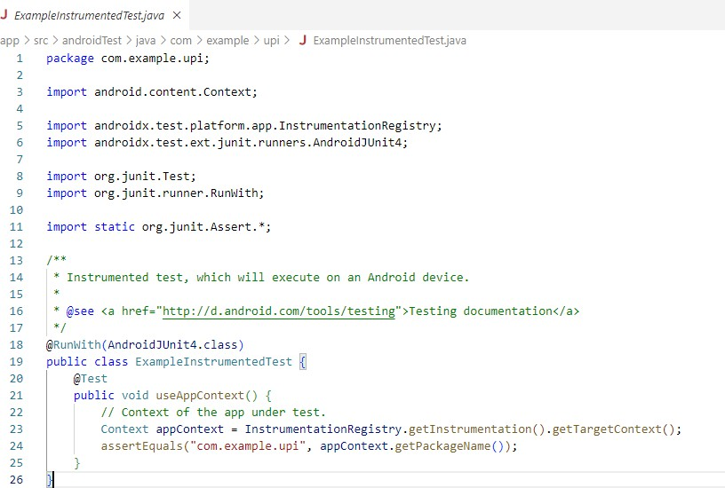

Fig 6.3.1 Integration code

SIMPLE UNIT TEST FOR ANDROID APPLICATION
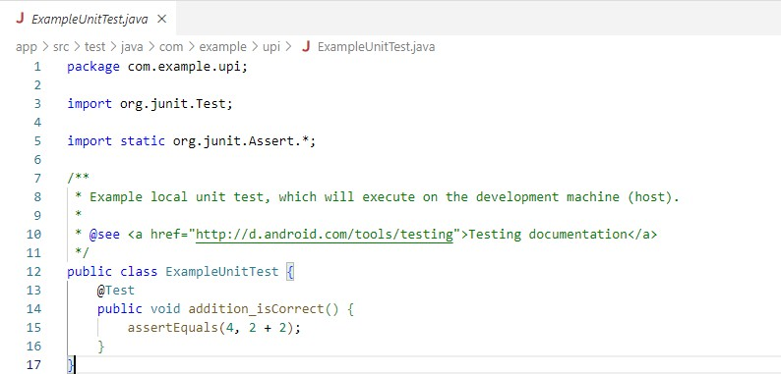

Fig 6.3.2 Unit Test Code

ANDROID WEBVIEW IMPLEMENTATION FOR LOADING UPI FRAUD DETECTION WEBSITE
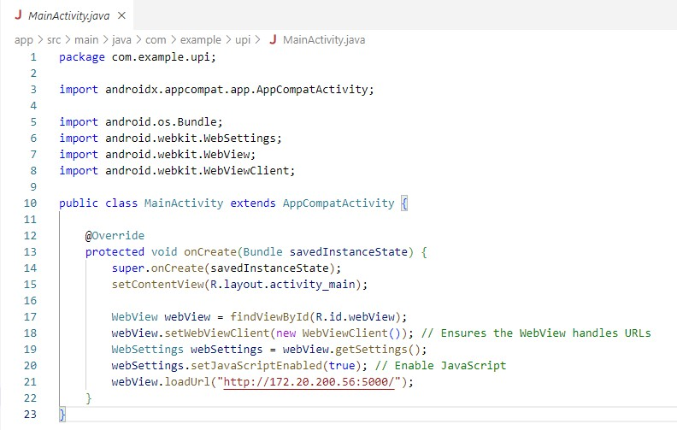
Fig 6.3.3 Upload Code

CNN FILE FOR WEBSITE
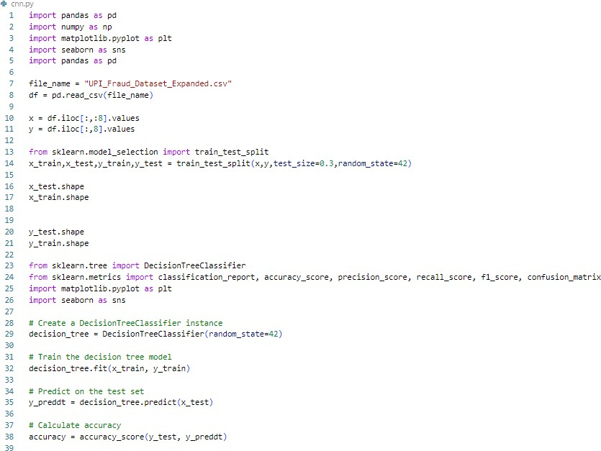
Fig 6.3.4 CNN File

CHAPTER 7
TESTING

TESTING

Testing is a crucial phase in the software development lifecycle to ensure the application meets functional and non-functional requirements. For the UPI fraud detection project, testing involves verifying:
    - Model Performance Testing: Accuracy, Precision, Recall, and F1 Score of the Decision Tree and CNN models were tested to ensure reliable predictions. accuracy score was calculated for both models to compare and select the best-performing one.
    - Integration Testing: Verifying seamless integration between the Flask application and TensorFlow model. Ensuring proper pre-processing (e.g., scaling) and compatibility of input features.
    - Functionality Testing: Upload functionality: Ensures that users can upload datasets and preview them correctly. Fraud detection: Testing input forms for correct data validation and ensuring accurate results. Web navigation: Testing routes like /login, /upload, and
/detect to ensure all templates load properly.

    - User Interface Testing: Ensures templates (login.html, result.html, etc.) display expected data and results. Testing responsiveness and clarity of the bar plot visualizing model accuracy.
    - Boundary and Edge Case Testing: Input validation for transaction amounts, dates, and missing or invalid data. Handling empty or corrupted datasets during upload.

SOFTWARE TESTING INTRODUCTION
Software Testing is the process of evaluating a software application to determine if it meets specified requirements and to identify defects. The primary objectives of testing are:

Validation and Verification:

  - Validation: Ensures the product meets user requirements (e.g., detecting fraudulent UPI transactions)

  - Verification: Confirms that the application behaves as expected in various scenarios.

Defect Identification:

  - Identify bugs or discrepancies in the application functionality, especially in fraud prediction logic.

Types of Software Testing:

  - Manual Testing: Verifying UI navigation and functionality without automation tools.
  - Automated Testing: Testing model predictions and data processing using scripts and testing frameworks (e.g., TensorFlow evaluation metrics).

LEVELS OF TESTING USED IN THE PROJECT

Unit Testing:

  - Verifies the functionality of individual components.
  - Examples: Testing the CNN model architecture to ensure it compiles and trains correctly. Testing input scaling using MinMaxScaler.

Integration Testing:

  - Focuses on the interaction between modules.
  - Examples: Ensures compatibility between the Flask app and the TensorFlow model. Testing the flow of data from the HTML form to the prediction function.

System Testing:

  - Validates the entire application as a whole.
  - Examples: Testing the end-to-end functionality: dataset upload, preprocessing, fraud detection, and result visualization. Ensuring that the predictions are displayed correctly in the result.html template.

Acceptance Testing:

  - Determines if the application meets business requirements.
  - Examples: Verifying if non-technical users can navigate the web app and interpret results. Confirming predictions are accurate and in line with stakeholder expectations.

TEST CASES

Test Case: Unusual Transaction Amount

      - Description: A user typically performs transactions of smaller amounts. A large sum is transferred in a single transaction.
      - Expected Outcome: The system should flag this as a potential fraud case.

Data:

        - User transaction history: Multiple small transactions of ₹100-₹500
        - Test transaction: ₹50,000 to an unfamiliar recipient

Test Case: Multiple Failed Authentication Attempts

      - Description: A user repeatedly tries to authenticate transactions with incorrect PINs or passwords, which may indicate account takeover attempts.
      - Expected Outcome: The system should block or flag the account for investigation.

Data:

        - User transaction history: 0 failed PIN attempts
        - Test scenario: 5 failed PIN attempts within 30 minutes

Test Case: Suspicious Transaction From Known Fraudulent Account

      - Description: A user has a history of legitimate transactions with multiple trusted accounts, but a transaction goes through to an account known to be flagged for fraud.
      - Expected Outcome: The system should flag this transaction as fraud.

Data:

        - User transaction history: Legitimate transactions with trusted accounts
        - Test scenario: A transaction to a flagged account from a blacklisted entity

Test Case: Sudden Change in Spending Pattern

      - Description: A user has a consistent spending pattern (e.g., mostly paying utility bills), but suddenly there is a shift in transaction types (e.g., frequent payments to online gaming sites).
      - Expected Outcome: The system should flag the change in pattern as potentially fraudulent.

Data:

        - User transaction history: Mostly utility bill payments, grocery shopping
        - Test scenario: Multiple transactions to online gambling sites

Test Case: Multiple Account Logins from Different IPs

      - Description: A user has always accessed their UPI app from a specific IP address, but there are sudden logins from multiple unfamiliar IPs.
      - Expected Outcome: The system should flag this as potential fraud.

Data:

        - User transaction history: Regular login from IP address A
        - Test scenario: Login attempts from IP addresses B, C, and D

Test Case: Multiple Refunds for the Same Transaction

      - Description: A user initiates a refund request for a single transaction multiple times, which is usually a red flag for money laundering or fraud.
      - Expected Outcome: The system should flag multiple refund attempts.

Data:

        - User transaction history: 1 refund per transaction
        - Test scenario: Multiple refund requests for the same transaction ID

CHAPTER 8
RESULT AND DISCUSSION

8.1 RESULT
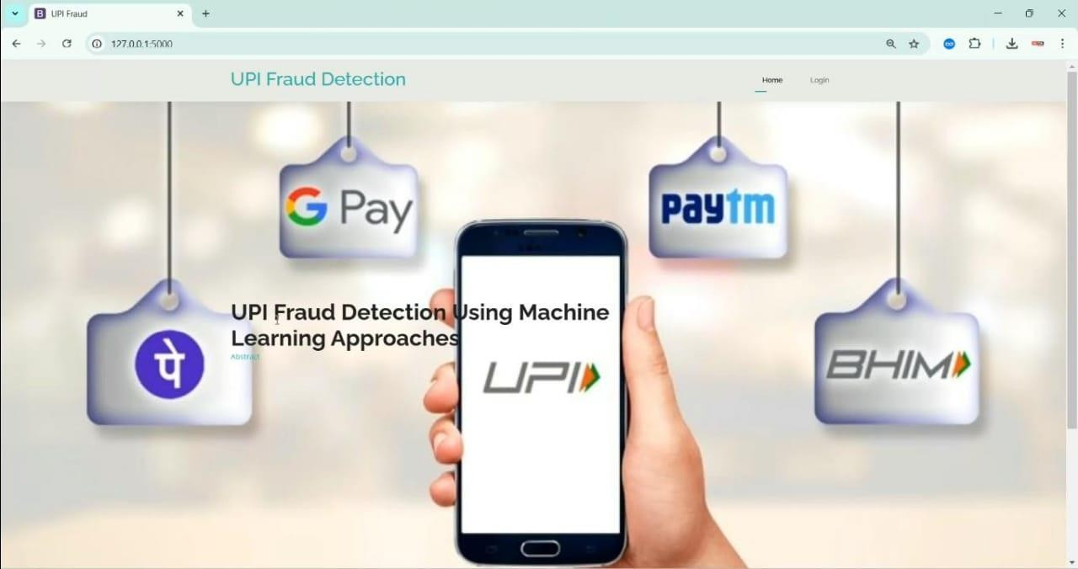

Fig 8.1 Home Page
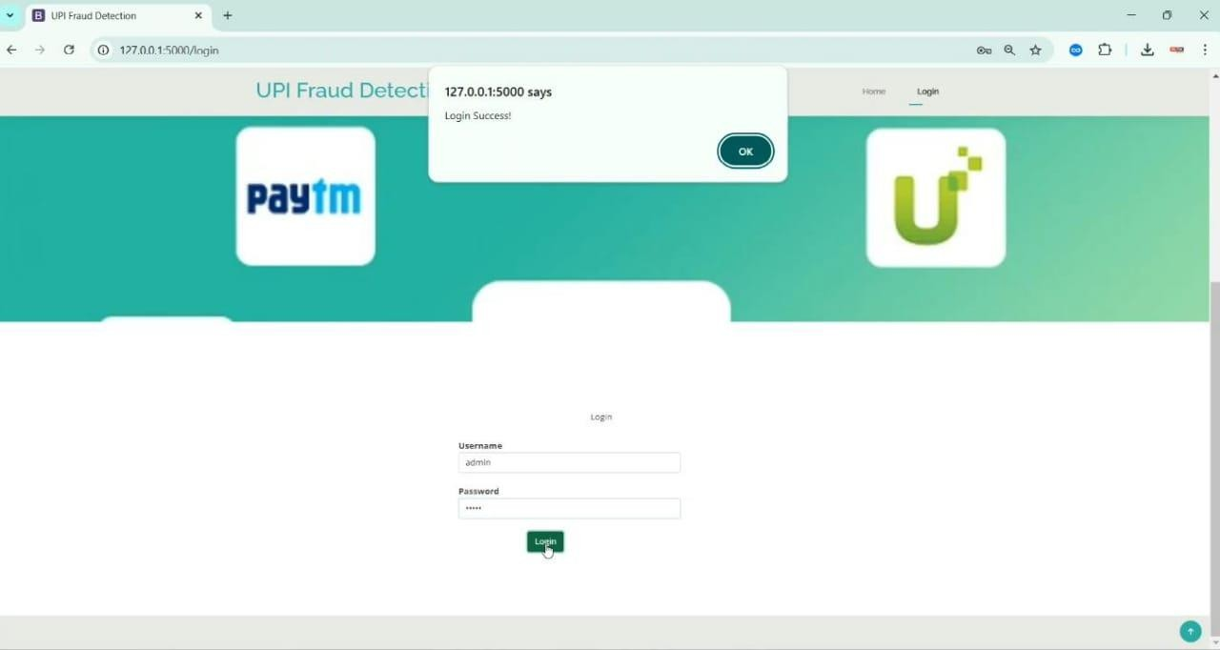

Fig 8.2 Login Page

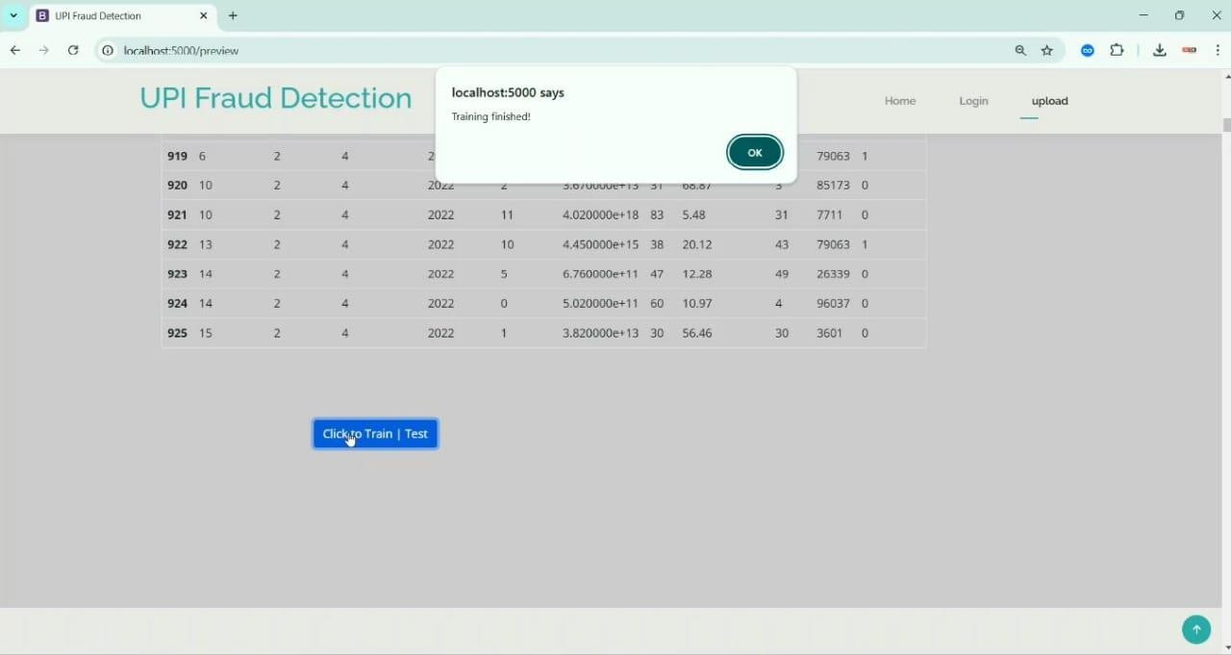

Fig 8.3 Upload Page
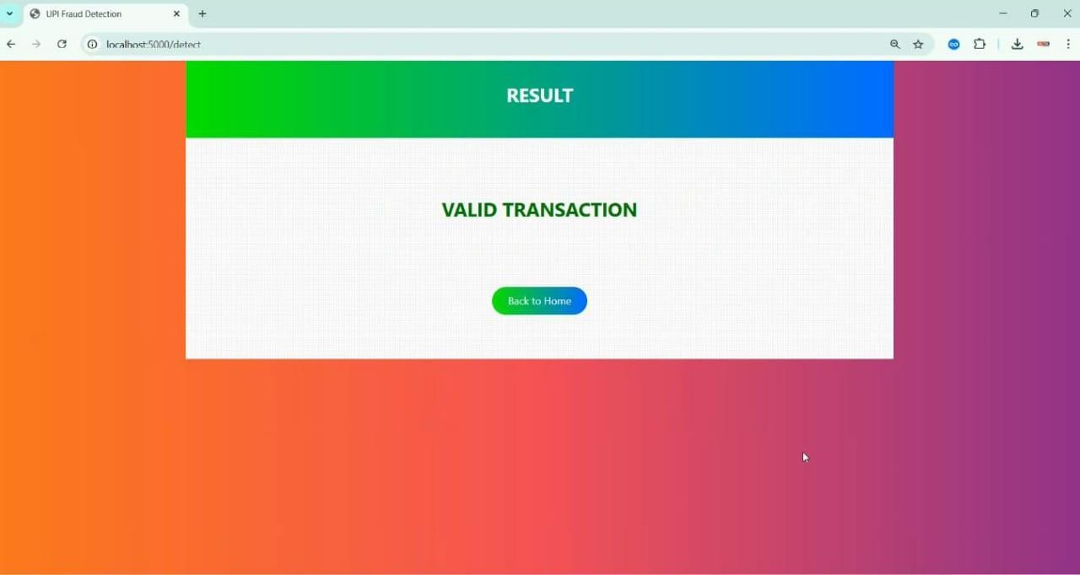

Fig 8.4 Valid Transaction

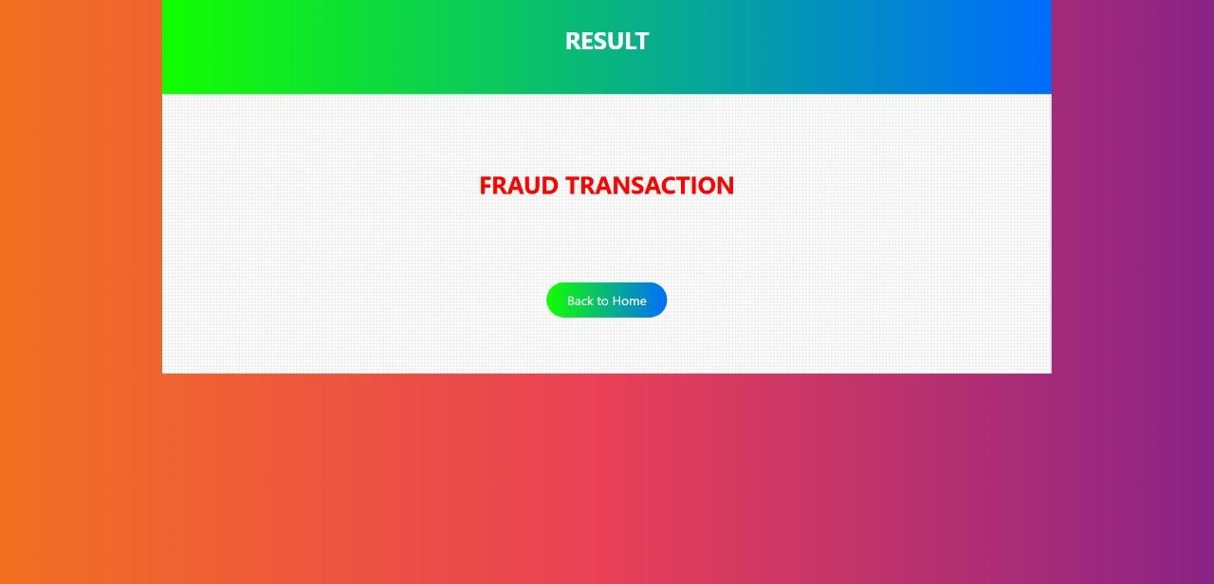

Fig 8.5 Fraud Transaction

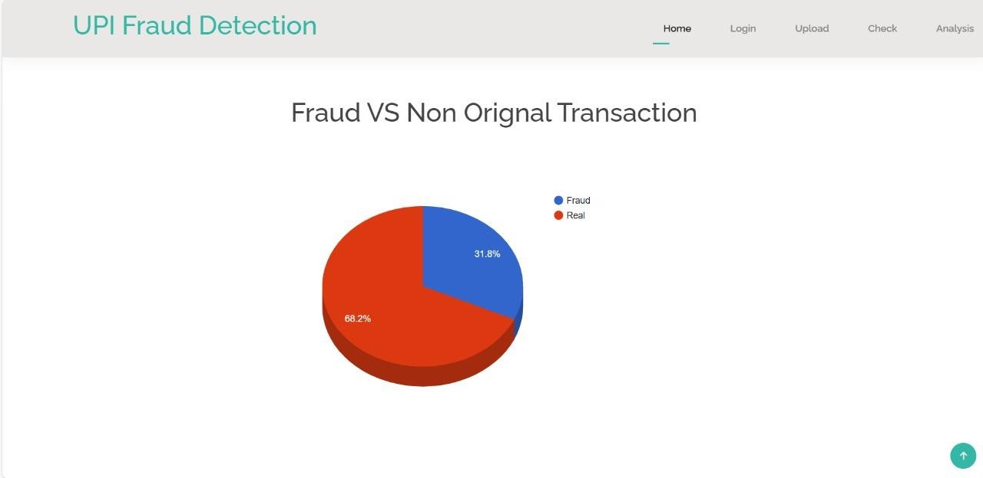

Fig 8.6 Pie Chart for Fraud Vs Original Transaction

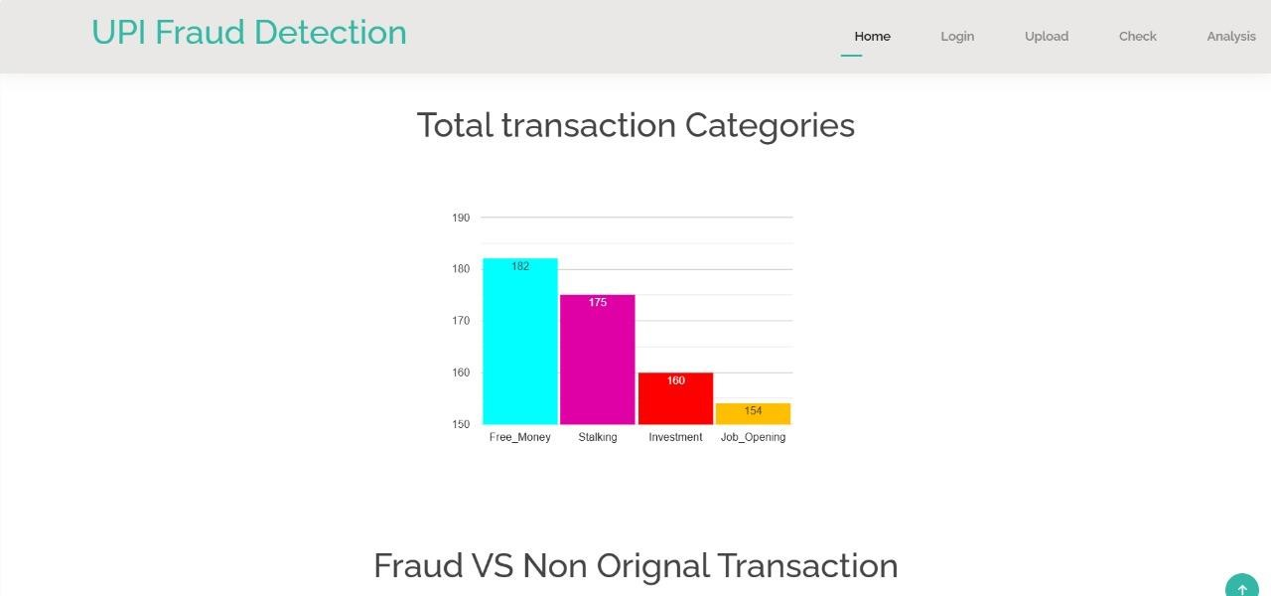

Fig 8.7 Bar Chart for Fraud Vs Original Transaction

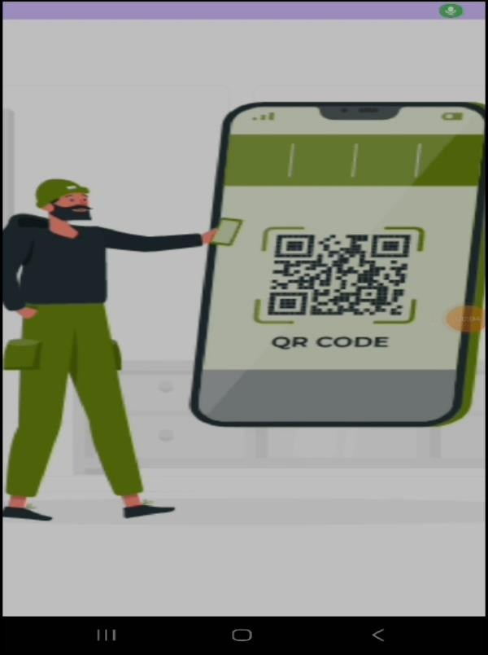
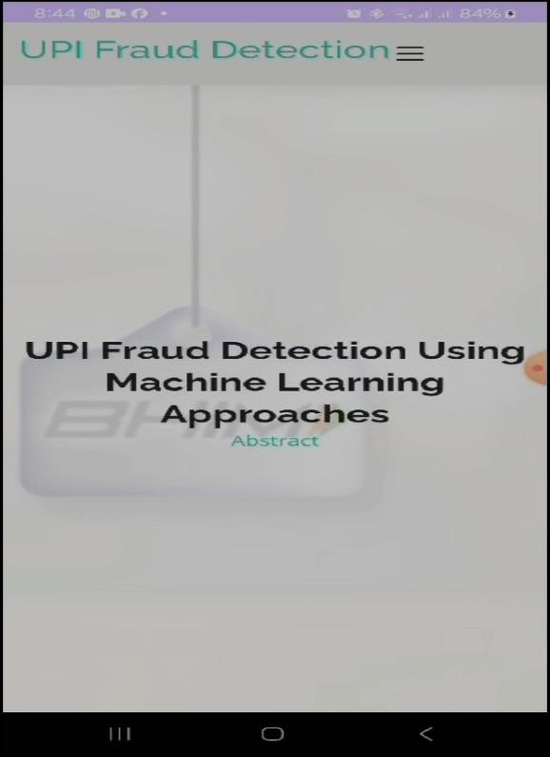

Fig 8.8 Android App Snapshot

CONCLUSION

Implementing UPI fraud detection using Machine Learning is a proactive approach to preventing fraudulent transactions and protecting users' financial information. By leveraging ML algorithms, UPI service providers can improve detection accuracy, reduce false positives, and enhance customer security. The UPI Fraud Detection System is a robust and efficient solution designed to address the growing concerns of fraudulent activities in digital payment systems. By leveraging advanced machine learning techniques, particularly Convolutional Neural Networks (CNNs), the system ensures high accuracy in identifying and preventing fraudulent transactions.

The system's architecture incorporates key stages, such as data preprocessing, feature extraction, and model training, which work cohesively to deliver reliable fraud detection. Through the use of clean and consistent data, the system enhances the quality of predictions and minimizes false positives. Additionally, the classification capabilities provide real-time insights to alert users and prevent potential financial losses.

This automated, data-driven approach ensures scalability and adaptability, making it suitable for dynamic environments and evolving fraud patterns. In conclusion, the UPI Fraud Detection System is an essential tool for maintaining the security and trustworthiness of digital payment platforms, safeguarding users and financial institutions alike from fraudulent activities.

FUTURE ENHANCEMENTS

- Real-time Transaction Monitoring: Implement real-time transaction monitoring to detect and prevent fraudulent transactions as they occur.
- Advanced Machine Learning Techniques: Explore advanced ML techniques, such as deep learning, graph-based methods, and transfer learning, to improve detection accuracy.
- Integration with Other Fraud Detection Systems: Integrate the UPI fraud detection system with other fraud detection systems, such as those used in banking and credit card transactions.

FRAUDIFY-FIGHTING FINANCIAL CRIME WITH ML CONCLUSION

- Use of Alternative Data Sources: Utilize alternative data sources, such as social media, device information, and behavioral data, to improve detection accuracy.
- Explainable AI: Implement explainable AI techniques to provide insights into the decision-making process of the ML model.
- Continuous Model Updating: Regularly update the ML model with new data and retrain to maintain its performance and adapt to changing fraud patterns.
- Collaboration with Law Enforcement: Collaborate with law enforcement agencies to share information and best practices in fraud detection and prevention.

BENEFITS OF FUTURE ENHANCEMENTS

  - Improved Detection Accuracy: Advanced ML techniques and real-time transaction monitoring can improve detection accuracy and reduce false positives.
  - Enhanced Customer Security: Integration with other fraud detection systems and use of alternative data sources can enhance customer security and prevent fraudulent transactions.
  - Increased Efficiency: Automated fraud detection and prevention can increase efficiency and reduce the need for manual intervention.
  - Better Compliance: Continuous model updating and collaboration with law enforcement can ensure better compliance with regulatory requirements and industry standards.

Dept. of CSE, BrCE
2024-25 36

RESEARCH PAPERS:

A Comprehensive Survey on Digital Payment Fraud Detection Techniques
This paper discusses various techniques for detecting fraud in digital payment systems, including UPI.

Machine Learning Approaches for Fraud Detection in Digital Payments
This paper highlights how machine learning algorithms can detect anomalies and fraudulent activities in UPI transactions.

Detection and Prevention of Financial Fraud in Mobile Payment Applications
Focused on mobile payment applications, including UPI, this study emphasizes strategies to identify fraudulent transactions.

REPORTS & ARTICLES:

Fraud Detection in Unified Payments Interface (UPI)
A report that covers common fraud types, challenges, and fraud detection mechanisms in UPI systems. Published by: National Payments Corporation of India (NPCI).

Cybersecurity in UPI Systems: Challenges and Best Practices

Insights into vulnerabilities in UPI systems and effective measures to mitigate fraud risks.

AI-Driven UPI Fraud Detection: Case Studies and Insights
A detailed report on how artificial intelligence is transforming fraud detection in UPI and other digital payment systems. Published by: Accenture Insights.

Snapshots
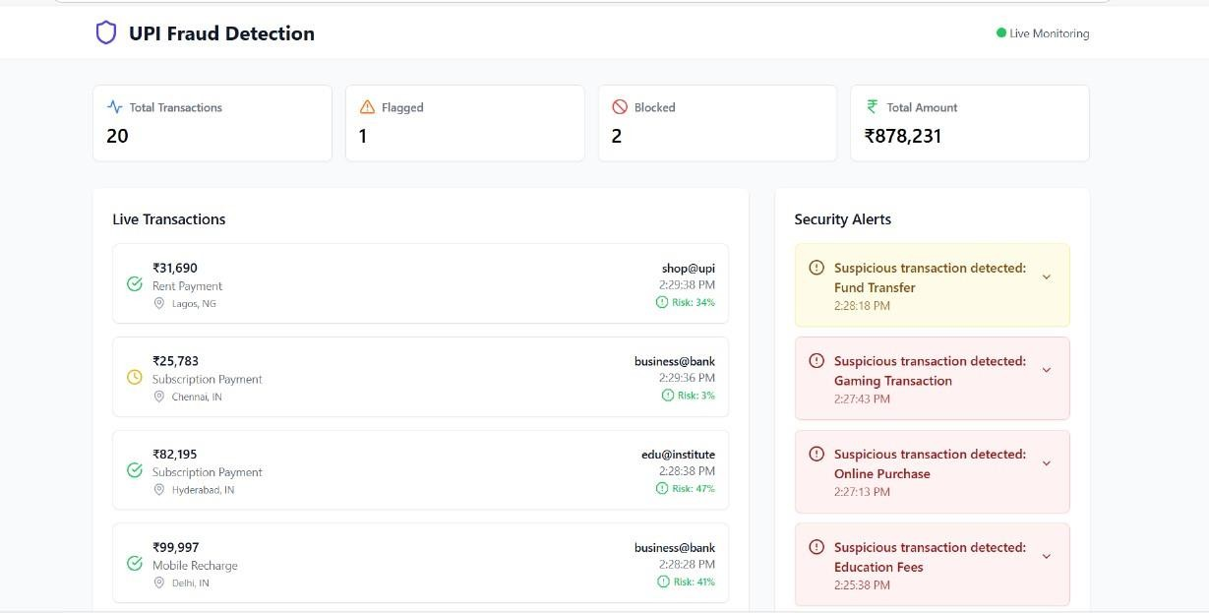

Fig 8.9 Dashboard

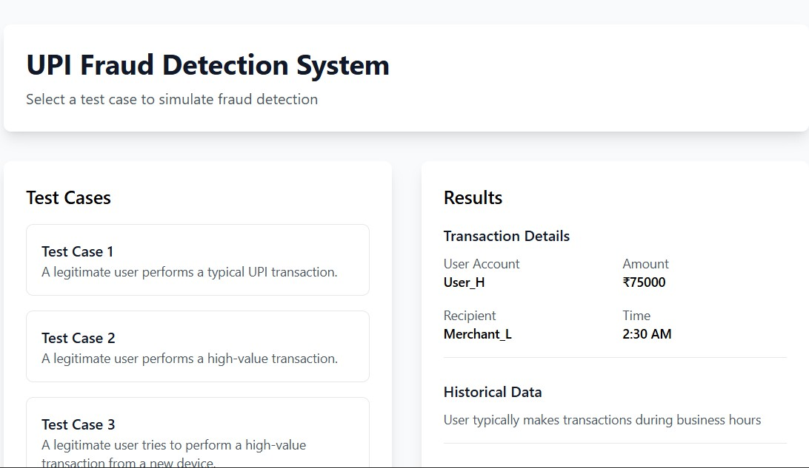

Fig 8.10 Test Case UI

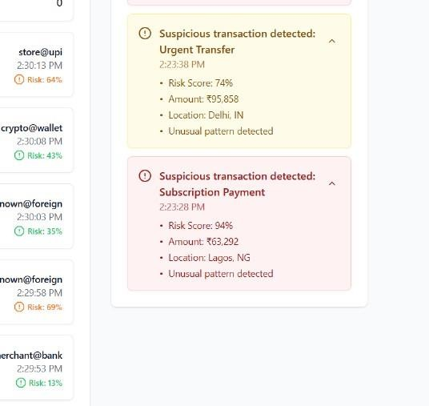

Fig 8.11 Suspicious Transaction

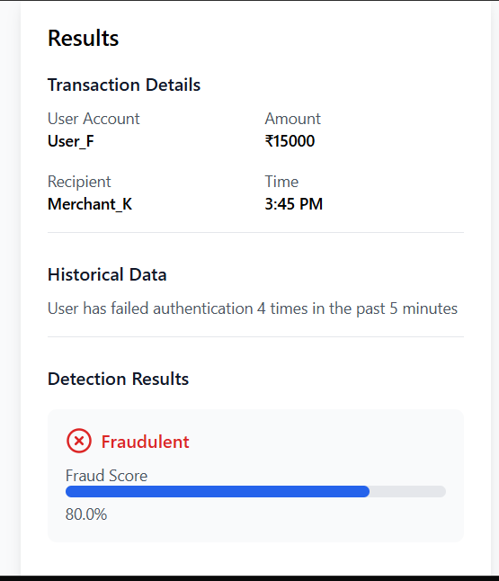

Fig 8.12 Fraudulent Result

APPENDIX B

ACRONYMS

Acronyms in UPI Fraud Detection using Machine Learning

In the context of UPI fraud detection using machine learning (ML), several important acronyms are commonly used. AI (Artificial Intelligence) and ML (Machine Learning) are at the core of the detection models. For detecting fraudulent activities, FRR (False Rejection Rate) and FAR (False Acceptance Rate) are key metrics to evaluate performance. AUC-ROC (Area Under the Receiver Operating Characteristic Curve) and F1 Score are used to assess the model’s accuracy in classification tasks. Models like SVM (Support Vector Machine), CNN (Convolutional Neural Networks), and RNN (Recurrent Neural Networks) may be applied to classify suspicious transactions. Techniques like SMOTE (Synthetic Minority Over-sampling Technique) help to address class imbalance in fraud detection datasets. Fraud- related issues are also managed using security protocols such as SSL (Secure Sockets Layer) and TLS (Transport Layer Security) to ensure safe transactions. Additionally, KYC (Know Your Customer) and AML (Anti-Money Laundering) regulations are essential for compliance and ensuring that the transaction histories of users are legitimate. Models are often trained on cloud platforms like AWS (Amazon Web Services) or GCP (Google Cloud Platform), and processes follow standards such as PCI DSS (Payment Card Industry Data Security Standard) for secure transaction handling. To measure and fine-tune model performance, algorithms such as XGBoost (Extreme Gradient Boosting) and techniques like PCA (Principal Component Analysis) for feature selection are often employed in the development phase.

